Hung-chi Chen (陳宏基) MD., Ph.D., F.A.C.S.
---Brief CV and picture
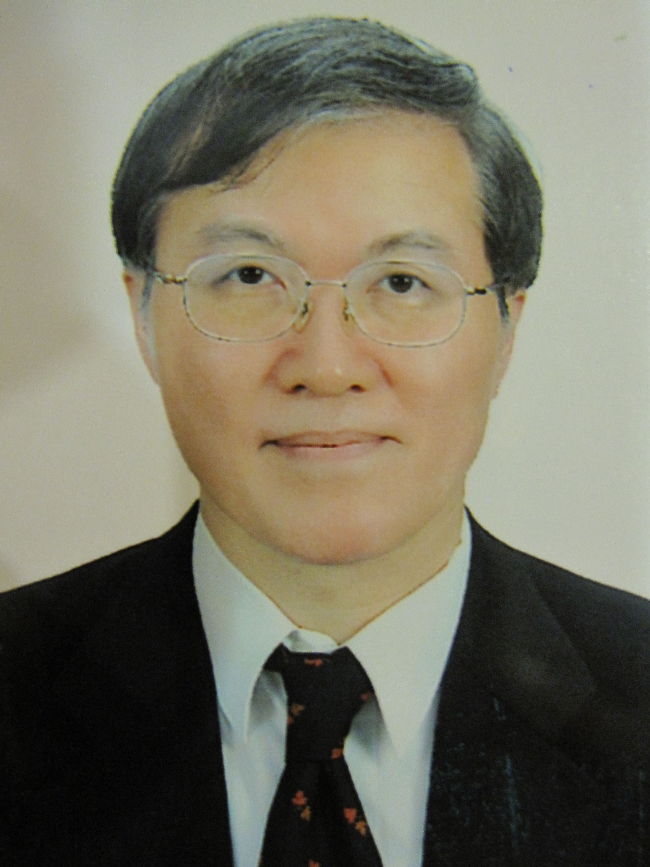

A brief CV for Prof. Hung-chi Chen
Prof. Hung-chi Chen is currently the Superintendent of International Center of China Medical University Hospital, as well as Professor of Plastic Surgery at China Medical University. He has 601 publications on microsurgery, 37 book chapters, a special book written on voice reconstruction using autogenous intestine, and 6 other books on Reconstructive Surgery. Most of his clinical work and research are in the field of complex microvascular reconstructive surgery, especially microvascular transfer of intestine for various reconstructive purposes, including reconstruction of esophagus and voice, urethra, vagina, etc., as well as the prevention of microsurgical complications. He was the only winner of the 2012 Award for Outstanding Contributions in Science and Technology of our country. He also won the Gold medal of 2014 National Biotechnology and Medical Care Quality Award, which represented the top achievement in a certain field of the world. In 2016 he was honored as Medical Elite of Taiwan offered by Discovery Channel. In 2017 he received the gold medal for International Service, as well as being invited as visiting professor by Harvard University. In 2018 he received gold medal by MOFA-Friend of Foreign Service. In 2019 he received Medical Contribution Prize offered by Legislative Yuan of ROC Government. Since 2020 he has got National Innovation Prize for 4 times. In 2024 he won the Diamond Prize of NHQA (National Health Quality Award) by our government. He had been invited as visiting professor and gave special lectures in 52 medical centers in the world,. He is also devoted to charity surgery for overseas patients of complex deformities from a variety of countries (such as Peru, India and Philippines), and has won excellent international reputation for his advanced knowledge and technology in complex reconstructive surgery.

